# [www.kieslermachine.com](http://www.kieslermachine.com/) [info@kieslermachine.com](mailto:info@kieslermachine.com) Toll Free : 888-565-6610

5" x 6 1/2" Stainless Steel Heavy Duty Hinges

|  |  |
| --- | --- |
| Model Number: 2875 LH - 316 | **Price: $ 735** |

* Maximum Door Weight: 3,000 LBS
* 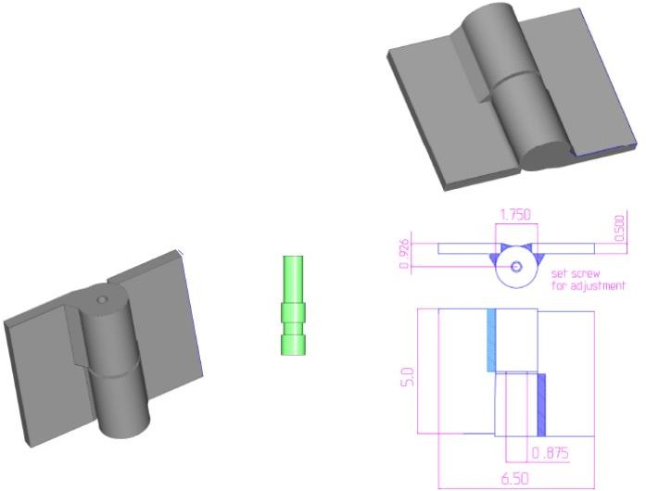Maximum Radial Load: 1,220 LBS
* Approx Width: 6 1/2"
* Height: 5"
* Leaf Thickness: 1/2"
* Weight: 7 LBS
* Mount: Weld On
* Material Type: 316L Stainless Steel
* Finish: Plain

[**Kiesler Machine Inc**](http://www.kieslermachine.com/) **Contact Info :**

# 13700 Chrissy Lane NE Palmyra, IN. 47164-8768

[info@kieslermachine.com](mailto:info@kieslermachine.com) Toll-Free : 888-565-6610

Phone : 812-364-6610

# Smoother Than The Rest Guaranteed!

Data Provided For Reference Only.

Disclaimer: This drawing is property of Kiesler Machine Inc, Kieslermachine.com. It is owned with the understanding that it will in no way be used in a manner which is harmful to Kiesler Machine Inc.